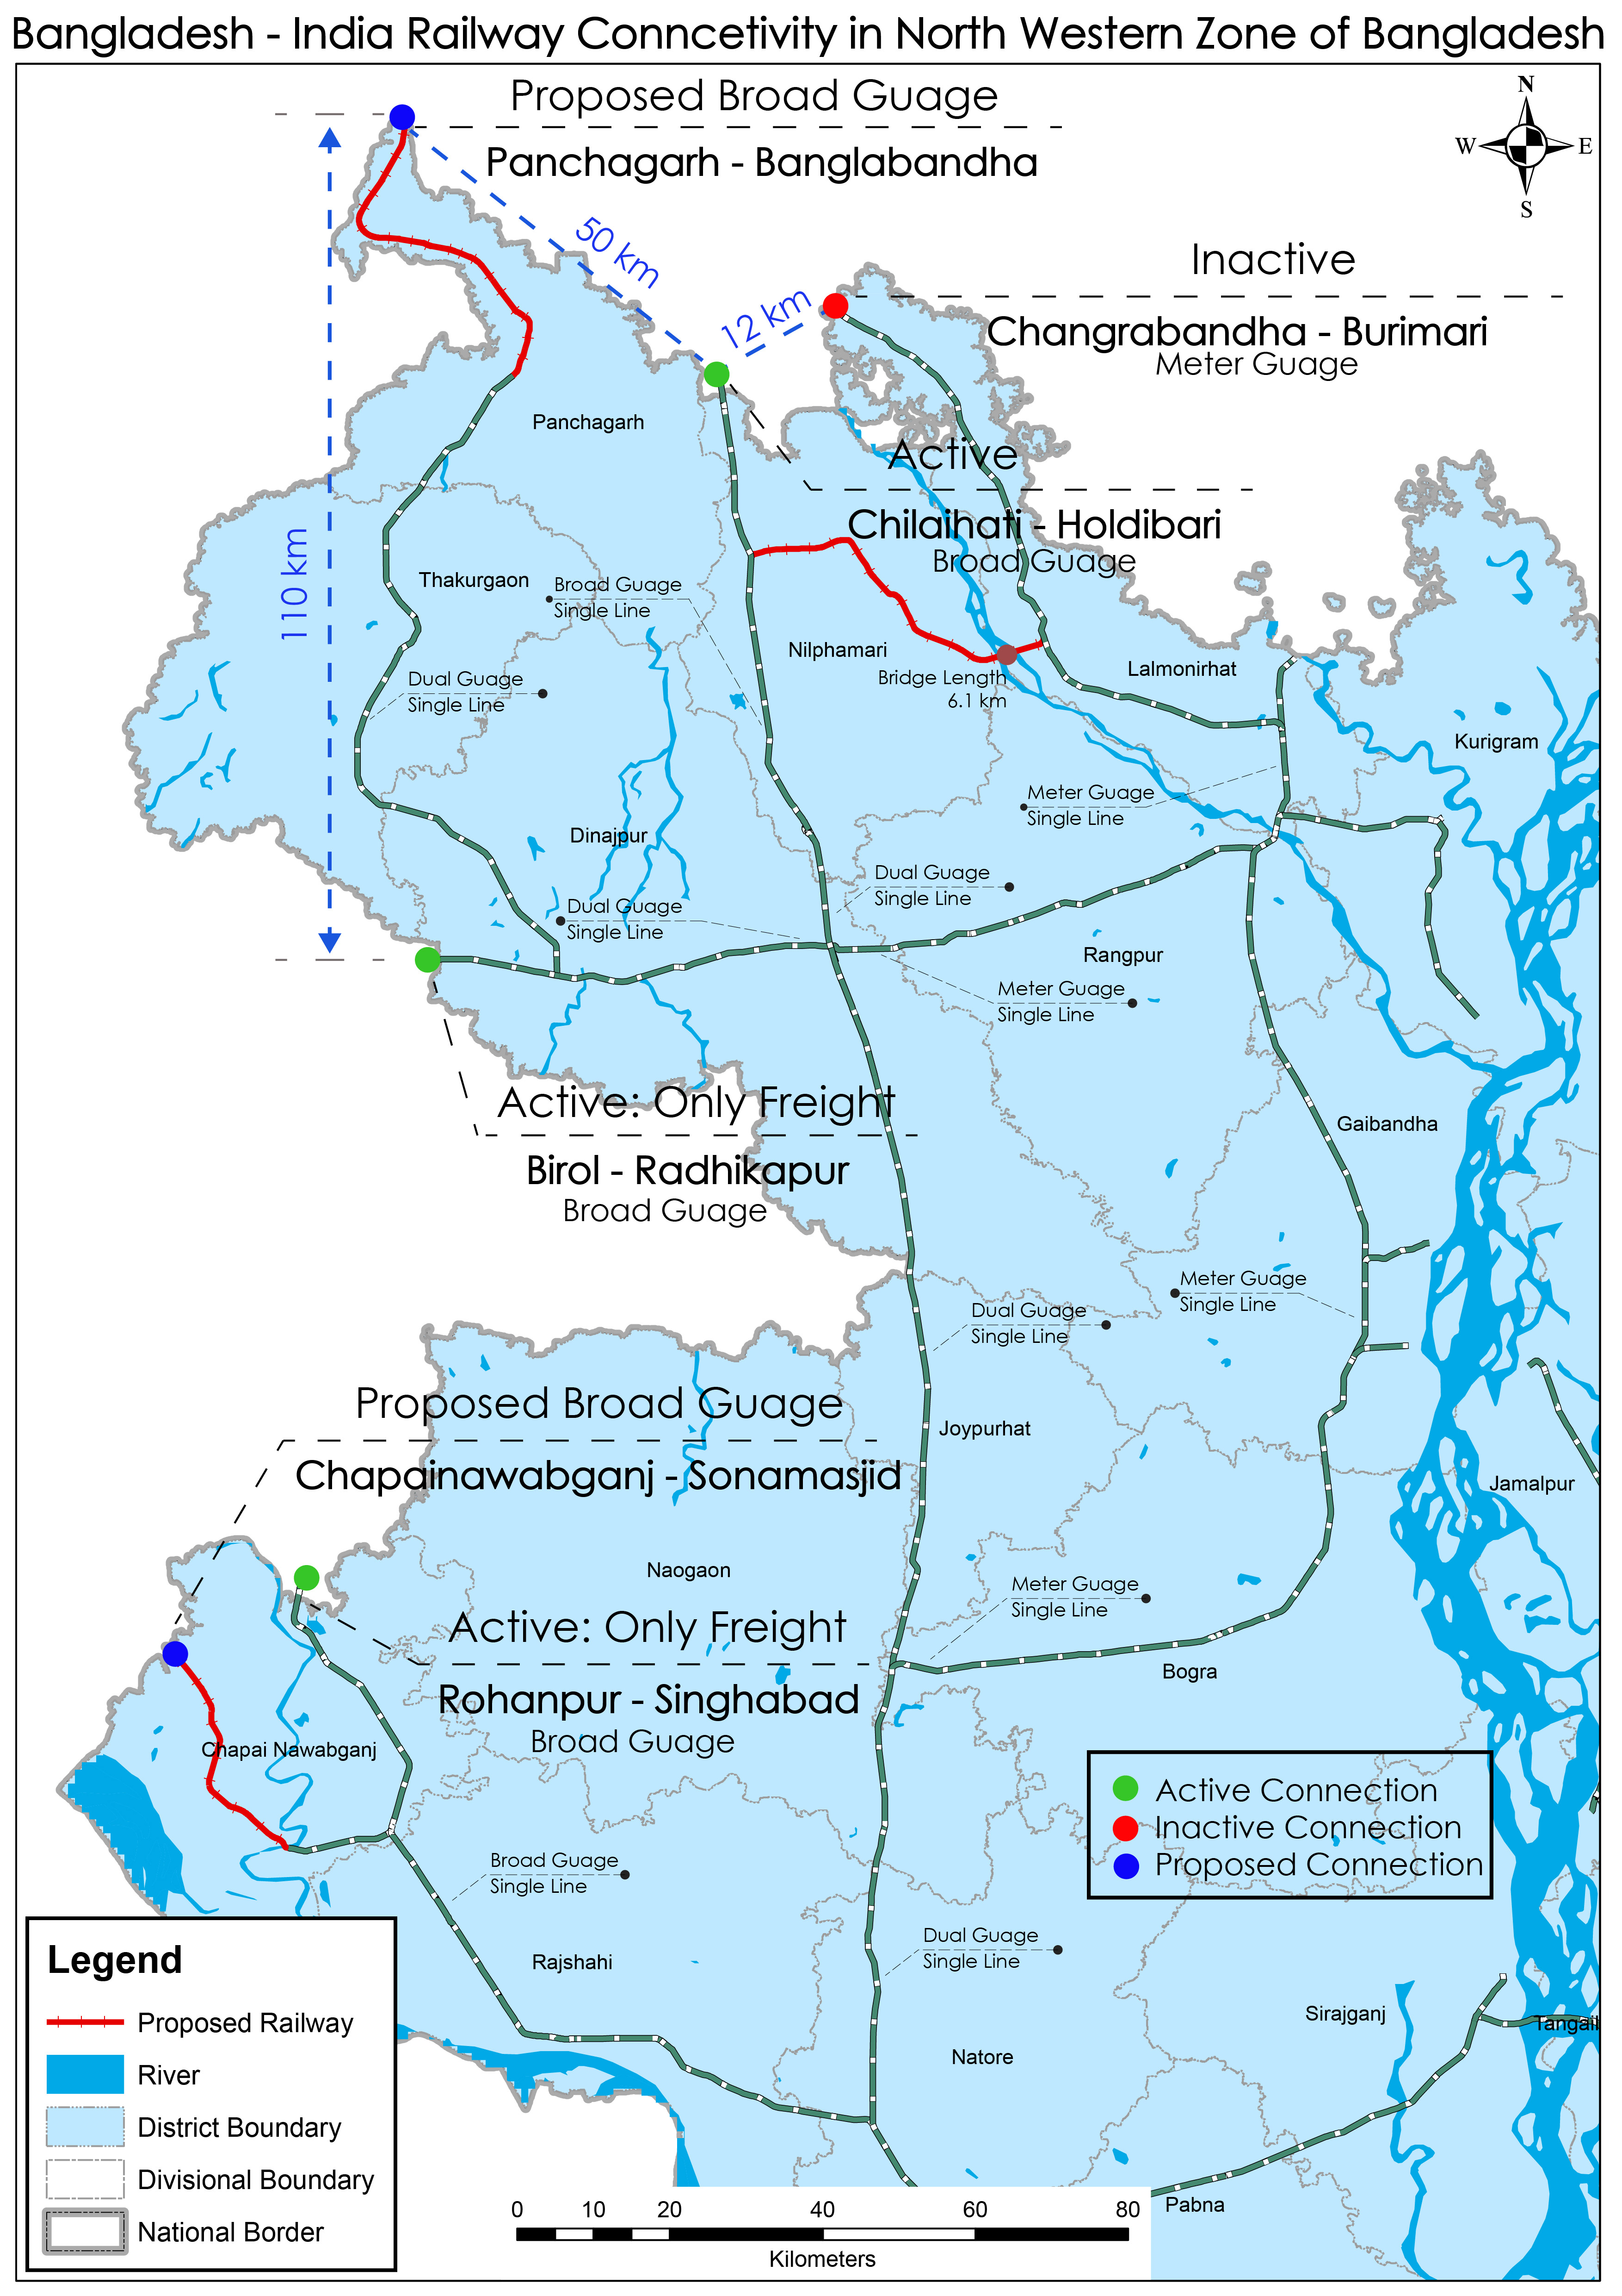
Chapainawabganj to Sonamasjid, Panchagarh to Banglabandha, Domar to Votemari Jaldhaka and Tista River

Assignment Name:
Consultancy Services for a) Feasibility Study for Construction of Railway line form (a) Chapainawabganj to Sonamasjid, (b) Panchagarh to Banglabandha, (c) Domar to Votemari via Jaldhaka and b) Feasibility Study, detailed design and preparation of bid documents for construction of new railway bridge on Tista River beside the existing railway bridge.
Name of Client:
Bangladesh Railway

Location:
Chapainawabganj to Sonamasjid, Panchagarh to Banglabandha, Domar to Votemari via Jaldhaka and Tista River.

Year of Completion:
February 2021

Project Description:
The Government of the People's Republic of Bangladesh has allocated public funds for the cost of "Feasibility Study for Important projects of West Zone" of Bangladesh Railway. The provision of the Services is: Consultancy Services for
(A)Feasibility Study for construction of railway line from
(a) Chapainawabganj to Sonamasjid, (b) Panchagarh to Bangabondhu, (c) Domar to Votemari via Jaldhaka and
(B) Feasibility study, details design and preparation of bid documents for construction of new railway bridge on Tista River beside the existing railway bridge.

Services Provided:
Feasibility Study & Preliminary Design, Detailed Engineering, Design and Preparation of Tender Documents

